1 – Integrated Visual studio extentions
1.1 – Conveyor By Keyoti
Purpose to use this library because avd,emulator does not support localhost to access library. So this library gives an local IT tour localhost and with help of this we can easily access APi in our app via emulator

Download reference
https://marketplace.visualstudio.com/items?itemName=vs-publisher-1448185.ConveyorbyKeyoti

Step to access
Download and install this library from above url
Run Visual studio in Run as administrator Mode
Then run your API/Project
Now IP will be provided by conveyor on left bottom side
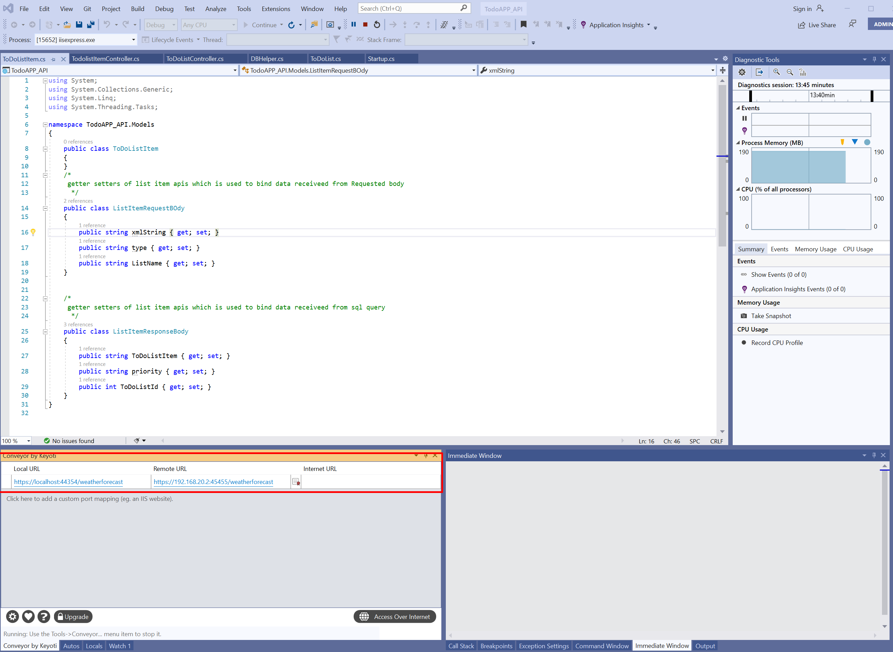

Now replace highlighted URL with local host in your code
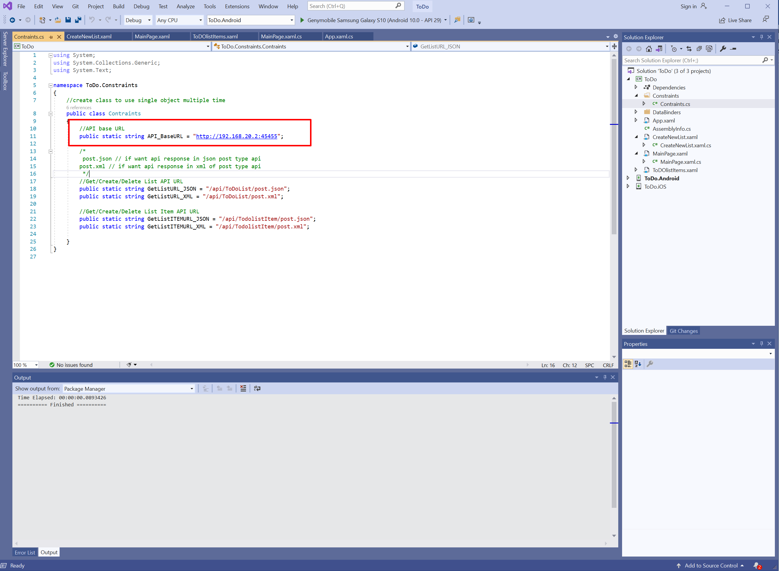

2 – Packages used in APP/API code
2.1- NewtonSoft Json (In App Code)
This library is used to convert/serialize or deserialize Json data
You can use this library by import package like
using Newtonsoft.Json;
if library not installed in app so you can download it from nuget package manager like 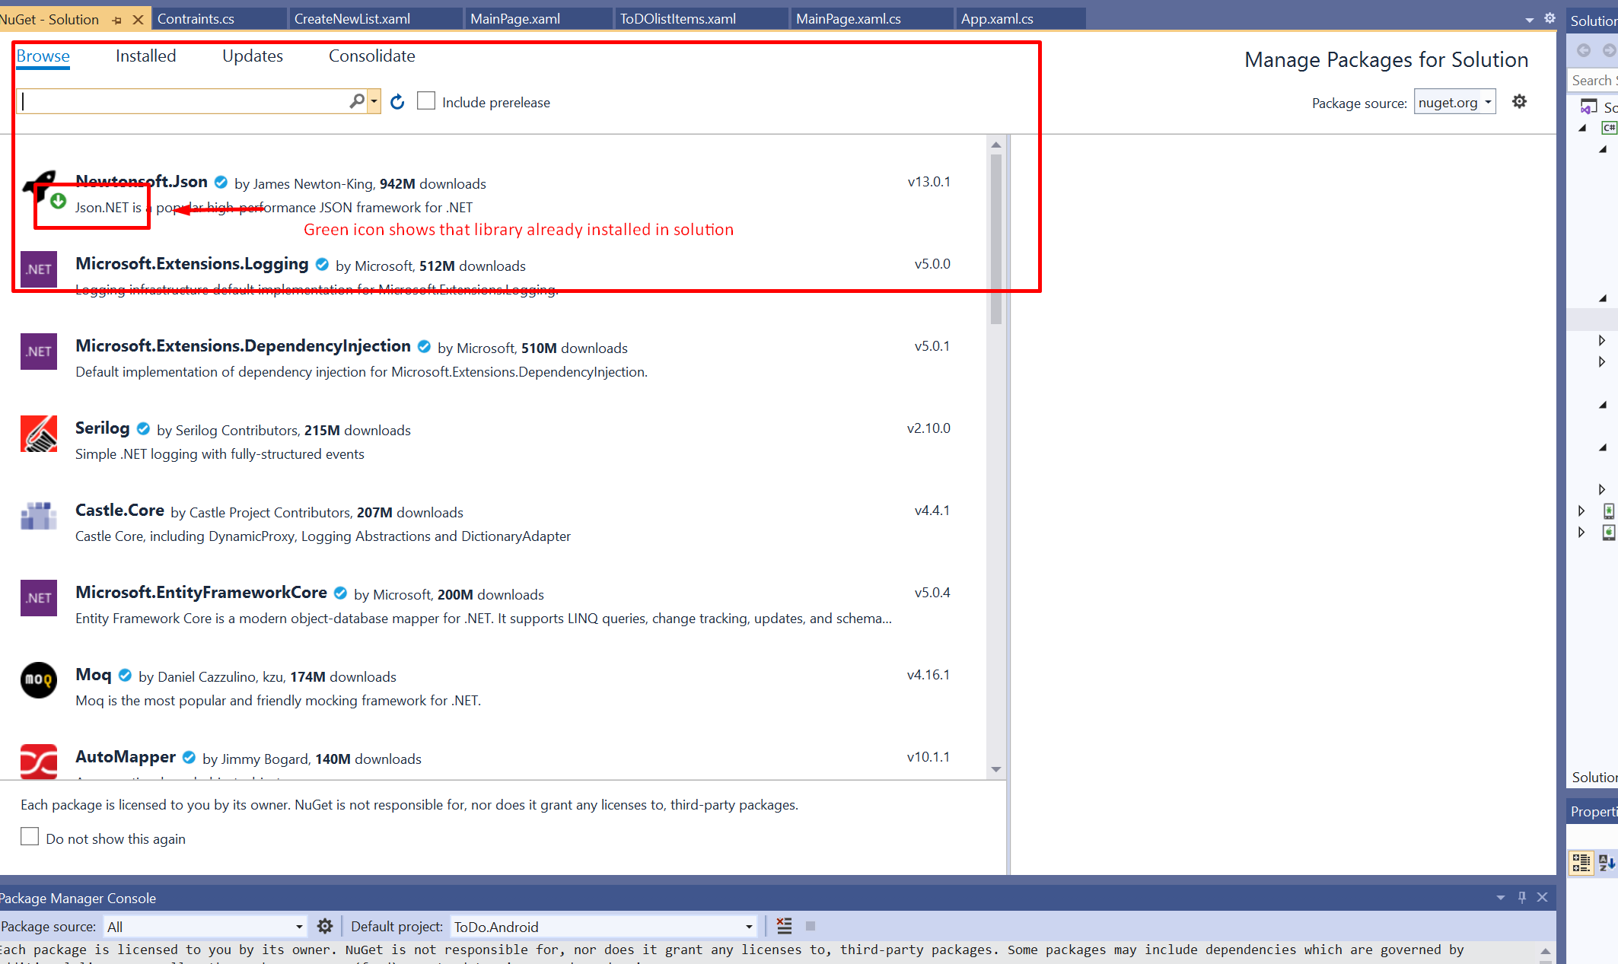

2.2 SqlClient / Sql data package(InAPI code)
These 2 package is used to interact with database for executing query/procedure etc
Import these library is as
using System.Data;
using System.Data.SqlClient;

you can add these from by click on reference -> add reference inside solution

3 – Important Libraries used definations
3.1 – In API code
AddXmlDataContractSerializerFormatters() – this is used in startup.cs to initialise response type of api by add annotation i.e
Apitype is type of api like get/post
{apitype}.json means api response in json
{apitype}.xml means api response in xml

AddMvc() – this is used in startup.cs to get MVC features in .net core api
IConfiguration – this class is used to read propery from appSettings.json file in api we used this to read connection string
[Route("api/[controller]")]- defines the call url mechanism where api defines that we need to hit api then controller which hits contructor of that apicontroller

[ApiController]- defines type of controller is of api type else it will be normal controller

[HttpPost("post.{format}"), FormatFilter] – Httppost is tag to convert our api to type of post if we want getAPI then use [HttpGet] then ("post.{format}") is used to define response of api like we want json or xml in api response and FormatFilter is convert response to type of response mentioned in {format}

DataSet – dataset is used to bind multiple select received from procedure execution
SqlConnection – use to open and close sql connection to execute sql command
SqlCommand – use to prepare sql command by passing query and connection string
SqlDataAdapter -to execute command mentioned above

3.1 – In APP code
HttpClient() – is used to call post parameterized API from app
StringContent() – is used bind request body,Request body format encoded,and default header of api we are calling

Async – Async is used because httpclient required async type of method to read api response.

NavigationPage() – used to set root of navigation page. This class is used to switching b/w pages and class which is called inside NavigationPageis always be root of navigation and this class is always be defined in app.xaml.cs file where our main base page is defined.

Navigation.PushAsync() - once our navigation page is defined. Than our base page is set to stack. Now we can easily travel from one page to another on button click or other event call using this class

Navigation.PopAsync() – this is used to go back from next page to previous page
Navigation.PopToRootAsync(); - this is used to redirect to root page of navigationPage and clear all stack generated via PushAsync() and PopAsync()

OnAppearing() – this is used to refresh page because on navigation by default page is not refreshing the data as per action performed on previous page so to get updated data we use this default function of Xamarin to update data.

3 – XAML tags used definations

Entry -is used to get editable taxt in xml
ListVIew – is to display data in list
Stack Layout – is to use to format page as per layout
Piker – is used to get/bind data in dropdown
Button – is used to get button

4 -XAML tags inner property definition

Text= is used to set text of tag

x:Name=ised to define unique name or id of that tag

HorizontalOptions= define orientation of tag

BackgroundColor= set background color of that tag

TextColor = set text of tag

Clicked= is used define clicked event in tag and pass function we need to pass function we needto call onclick

ListView – is used to create list view and bind data inside list

